

|  |  |
| --- | --- |
| DATE: | 27TH SEPTEMBER 2023 |
| PROJECT NAME: | NOISE POLLUTION MONITORING SYSTEM |

**INTRODUCTION:**

The main objective of IOT based air and noise pollution monitoring system is that the air pollution is a rising issue these days. As a human we need fresh air to survive. Air is most important factor in humans life. If there is any kind of air pollution it’s harmful for human. Air pollution kill more than seven million people worldwide every year. Pollution is very harmful for those people who have any kind of internal diseases on this type of people pollution affect very fastly. In atmosphere is the full of air which contain monoxide, smoke, alcohol, benzene, methane etc.

Between this gases some are good and some are harmful for environment for certain level some gases are good for human, animals, plants but beyond certain level these created problem for services to overcome these problem system is useful because of this we can analyse the air and noise pollution means how many pollution level in atmosphere in three different levels. We use Internet Of Things (IOT). In this we use thingspeak we can analysis previous data also using this platform in graphical form.

**PROBLEM STATEMENT:**

An effective natural observing framework is essential to screen and estimate the conditions in the event of surpassing endorsed level of parameter (for example, commotion, CO and radiation levels). At the point when the items like condition furnished with sensor gadgets, smaller scale controller and different programming application turn into a self-securing and self-observing condition.

# OBJECTIVES

1. To study the existing system.
2. To design the block diagram.
3. To decide the components specification &device in system.
4. To design the circuit diagram and simulate it using suitable software.
5. To design the PCB and implement hardware.
6. To test the circuit and observe the result.

**Block diagram**



**Power Supply**

**Air Quality Sensor**

**LCD Display**

**Cloud**

**WIFI module**

**ThingSpea**

**LED**

**Sound Sensor**

**Buzzer**

**Arduino uno**

In system we use arduino as main controller. In system we use MQ135 gas sensor for

detecting or sensing gases and also use sound sensor LM393 module for detect the sound pollution. Sensed data of sensor given to analog pin of the arduino then digital output pin are connected to LCD, buzzer and LED. If air pollution is there then buzzer will start beeping and if sound pollution is there then LED will glow. All condition of pollution display on LED and we can also analyze past data using thing speak in graphical form.

Arduino is an open source prototype. Software will operate in Arduino IDE Computer code can be written and upload to the physical board. Arduino board is a board that can be functioned via Arduino IDE by sending a set of instructions to the microcontroller on it. For controlling Sensors. For arduino programming we are going to use Embedded C. We are going to build project in Embedded C and for monitoring that project we are using Cloud.

# COMPONENTS

1. ArduinoUNO
2. MQ135 (Gassensor)
3. LM393 (Noisesensor)
4. ESP8266 WIFIModule
5. 16*2 LCDDisplay
6. LED
7. Buzzer

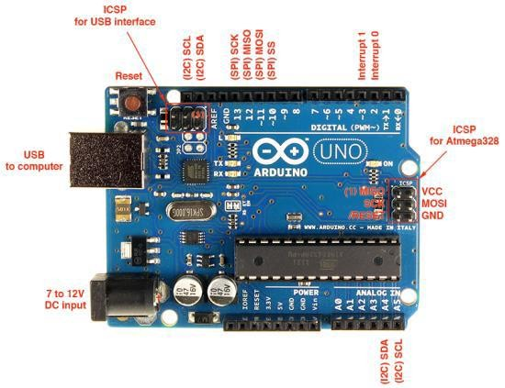**ARDUINO BOARD**

Arduino is 8 bit microcontroller board based on the ATmega328P. The operating voltage is 5V. It has 14 pins digital input output pins (Of which can be used 6 as PWM output)

Oscillator frequency is 16 MHz It contains everything needed to support the microcontroller simply connect it to a computer with USB cable. It has 6 analog input pins.

# Feature

* Operating voltage is5v.
* DC current per input pin is 40mA.
* Clock speed16MHz.
* DC current for 3.3v pin is 50mA.
* SPAM 2 KB
* EEPROM 1KB

# MQ135 Gas Sensor

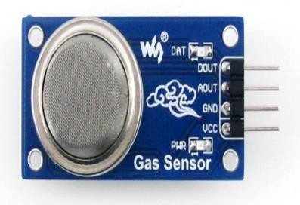

The MQ135 is a gas sensor it used for detecting or sensing harmful gases in the atmosphere. It has wide detecting scope. It gives fast response and also it it high sensitivity sensor. It is simple and long life device. They are used in air quality control equipment for building offices are suitable for detecting of NH3, alcohol, benzene, smoke CO2 etc.

# Feature

* Wide detecting scope
* Fast response and High sensitivity
* Stable and long life
* Operating Voltage is +5V
* Detect/Measure NH3, NOx, alcohol, Benzene, smoke, CO2, etc.
* Analog output voltage: 0V to 5V

# LM393 Sound Sensor

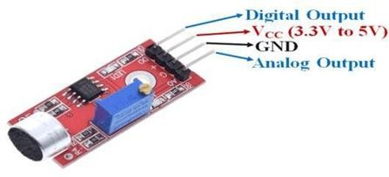

The sound sensor module provide an easy way to detect sound and it generally used for detecting sound intensity. Module detect the sound has exceeded a threshold value. Sound is detected via microphone and fed into an LM393 op-amp. The sound level adjust through pot. The sound increases set value output is low.

These module work on DC 3.3-5 voltage.

# Feature

* Operating voltage 3.3V-5V
* Output model: digital switch outputs (0 and 1, high or low level)
* Voltage Gain 26dB
* Microphone Impedance 2.2kΏ
* Microphone Frequency 16.20 kHz

# ESP8266 WIFI Module

The esp8266 WIFI module is a self contained soc with integrated TCP/IP protocol stack that can give any microcontroller access to your WIFI network. The esp8266 is capable of either hosting an application or offloading all WIFI networking functions from another application processor.

# Feature

* 2.4 GHz Wi-Fi (802.11 b/g/n supporting WPA/WPA2).
* General-purpose input/output (16 GPIO).
* Inter-Integrated Circuit (I²C) serial communication protocol.
* Analog-to-digital conversion (10-bit ADC).
* Serial Peripheral Interface (SPI) serial communication protocol.

# 16*2 LCD Display

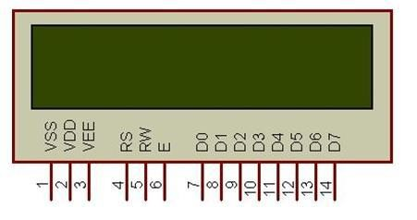

LCD is used for to display the condition there are three conditions in air pollution and three conditions in noise pollution means air and sound is clear, moderately polluted or highly polluted that is displayed on LED.

# Feature

* Operating Voltage is 4.7V to 5.3V
* Current consumption is 1mA without backlight
* Alphanumeric LCD display module, meaning can display alphabets and numbers
* Consists of two rows and each row can print 16 characters.
* Each character is build by a 5×8 pixel box
* Can work on both 8-bit and 4-bit mode

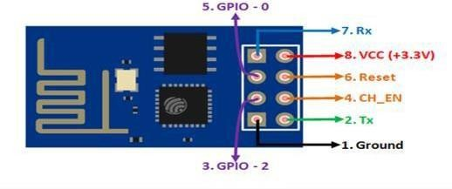

# ALGORITHM

1. Start Arduino UNO.
2. initialize LCD, gas sensor & noise sensor
3. Establish WITI connections.
4. If connection successful. next step else go to step 1
5. Read sensor values.
6. If Sensor value available establish TCP connection else read values again.
7. Establish TCP connection
8. If TCP connections successful. send data to server (Thingspeak). else set go to step 7
9. If TCP connections successful. send data to server (ThingSpeak). else set gob to step 7
10. Check for acknowledgement.
11. If acknowledgement received. go to step some time & else wait for go to step no 5.

# ADVANTAGES

1. Sensors are easily available.
2. Sensors are effortlessly accessible.
3. Detecting of wide range of gases.
4. Simple, compact and easy to handle.
5. Sensors have long life time.
6. Low cost
7. Data can be used to control pollution.

# APPLICATIONS

1. To estimate the pollution.
2. Indoor Air Quality Monitoring.\
3. To design server and upload data on that server with date and time.
4. We can use it at industrial area as there is lot of noise pollution
5. In city roads traffic noise.
6. Activities like shooting, open air events, football and cricket matches.
7. At small level, in schools and colleges we can use this device.
8. Automation Automation.

# FUTURE SCOPE

In future we modify the system to notify a user about the air quality and noise level it reaches beyond permissible level through SMS or app.

We can monitor air and sound pollution level at any place of the world.

**SOLUTION**

 Here we propose an air quality as well as sound pollution monitoring system that allows us to monitor and check live air quality as well as sound pollution in a particular areas through IOT. System uses air sensors to sense presence of harmful gases/compounds in the air and constantly transmit this data to microcontroller. Also system keeps measuring sound level and reports it to the online server over IOT. The sensors interact with microcontroller which processes this data and transmits it over internet. This allows authorities to monitor air pollution in different areas and take action against it. Also authorities can keep a watch on the noise pollution near schools, hospitals and no honking areas, and if system detects air quality and noise issues it alerts authorities so they can take measures to control the issue.

# CONCLUSION

By using this project each and every variation we can analyze and inform nearby people in time. We can also analyze data form home using thingspeak.

The most important factor of this system is that it is small, cost efficient and portable. Sensors are available easily anywhere. This system fully helpful to save the lives and overcome all the problem related to environment.